CURRICULAM VITAE
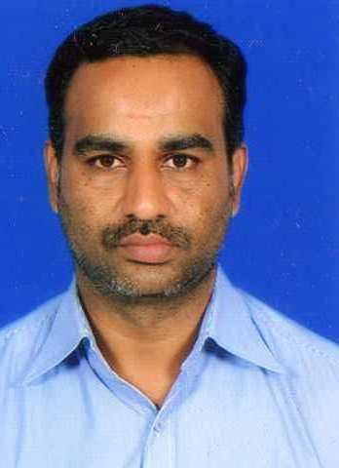

1. Name : A.U. SHABEER AHAMED

2. Sex : Male

3. Designation : Assistant Professor

4. Marital Status : Married

5. Nationality : Indian

6. Religion : Muslim - Labbai

7. Date of Birth
and Age : 12-02-1979, 43 yrs

8. Address for Communication:

Residence Office
No: 11, J. K Nagar, Department of Computer Application
Near Khajamalai main road, Jamal Mohamed College
Trichy- 620 023. (Autonomous)
E-mail: shabeerahamed5000@gmail.com Trichy-620020
Mobile: 9994459965

9. Educational Qualification:

DEGREE | SUBJECT | UNIVERSITY | YEAR OF PASSING
B.Sc | Physics | Jamal Mohamed College  (Autonomous), Trichy | 2001
M.Sc (IT) | Information Technology | Jamal Mohamed College  (Autonomous), Trichy | 2003
M.Phil | Computer Science | Bharathidasan University  Trichy | 2007
M.B.A | Business Administration | Bharathidasan University  Trichy | 2014

10. Teaching Experience:
UG and PG : 15 Years and 2 Months

11. Language Known : English, Tamil & Urdu

12. Area of Specialization : Digital Electronics, DBMS.

13. Subjects Taught:

Undergraduate: 1. Office Automation
2. C and C++
3. Computer Architecture
4. Management Information System
5. Multimedia and its Applications
6. Digital Electronics
7. Python Programming
8. HTML, PHP, Java Script
9. VB Dot Net
10. DBMS
11. Data Structures and Algorithms
12. Computer Networks

14. Seminars / Conferences / Workshops Attended:

- Participated in National Seminar on EXAMINATION REFORMS on
February 24, 2012 at Jamal Mohamed College, Trichy.

- Participated in ONE DAY Seminar on INERNAL QUALITY
ASSURANCE CELL organized by Internal Quality Assurance Cell,
Jamal Mohamed College, Trichy during 7th March 2012 .

- Attended ONE DAY STATE LEVEL WORKSHOP ON IMPORTANCE
OF SOFTSKILLS organized by National Service Scheme on
26th February 2013.

- Participated in NATIONAL CONFERENCE ON ADVANCED COMPUTING organized by PG & Research department of Computer Science, Jamal Mohamed College, Trichy on 7th March 2013.

- Attended TWO-DAY WORKSHOP ON RESEARCH METHODOLOGY IN COMPUTER SCIENCE held on 2nd and 3rd March 2014 in
Jamal Mohamed College.

- Participated in NATIONAL CONFERENCE ON ADVANCED COMPUTING organized by PG & Research department of Computer Science, Jamal Mohamed College, Trichy on 5th March 2014.

- Participated in a Two-week ISTE WORKSHOP on Computer Programming conducted by Indian Institute of technology Bombay (One week of equivalent work completed online from 20th May to 15th June and Physical participation at Remote centre (NIIT, Trichy) from 16th - 21st June 2014)

- Participated in FOUR DAY workshop on LATEX and SPSS organized by
PG and Research Department of Mathematics, Jamal Mohamed College on
26th, 29th, 30th September 2014 and 1st October 2014.

- Attended STATE LEVEL SEMINAR ON COMPUTING AND COMMUNICATION TECHNOLOGIES organized by P.G Department of Information Technology, Jamal Mohamed College on 25th February 2015.

- Participated in NATIONAL CONFERENCE ON ADVANCED COMPUTING organized by PG & Research department of Computer Science, Jamal Mohamed College, Trichy on 5th March 2015.

15. Online Course Attended:
- Completed an Online Course in
“Developing Soft skills and Personality” through NPTEL
held from August – October 2019.

16. Resource Person:

- Acted as a Resource person in KPR College of Arts Science and Research, Coimbatore.
Topic: Applications of Digital Electronics in
Computer Science.
- Acted as a Resource person in various institutions for PG-TRB Computer Science classes for Competitive Examinations from 2018 - 2019 .

17. Online Webinar Attended:
- “Glimpse of Ethical Hacking” on May 23, 2020.
- “Micro & Nanotechnology and its Applications” on May 14, 2020.
- “Tools to enhance learning and Teaching” on 11th May 2020.

18. Online Faculty Development Programme (FDP) Attended:
- “Artificial Intelligence and Machine Learning” 18th to 22nd October 2021.
- “ Online FTP Programme in Data Science and SAP” on 18th May 2020.
- Artificial Intelligence and Machine Learning using R Programming
From 6th to 10th December 2021 (ATAL Academy)
- Regaining Effective Creativity and Peace of Mind From
15th to 19th November 2021 (ATAL Academy)

19. Extra Curricular Activities:

- Passed LOWER Level in English Type Writing.
- Undergone Diploma in RETAIL MANAGEMENT
20. Other informations:

- Worked for one and half years as a Programmer-Cum-Faculty in
AL-Jamieathus Sadhik Matriculation School, Khajamalai, Trichy from
2004 to 2005.
- Worked for 3 years as a GUEST LECTURER in Govt. Arts College, Tiruverumbur, Trichy, from June 2005 to May 2008.
- Currently working as a Assistant Professor in Jamal Mohamed College, Trichy, from June 2008 to till date. (15 years)

21. Declaration:
I hereby declare that the above-mentioned details are true to best of my knowledge and belief.

Signature of the Staff

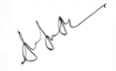

(A.U. Shabeer Ahamed)

